Major Project 3

Psych 350

By Alexandria Boyd

Group Members: Erika Rosenberger, Christopher Knowles, Amy Feher, and Erik Lasaine

Lab: TR 11am-12:20pm (Luyao Zhang)

Abstract

Comparison of the “Real Self” with the “Ought Self” and the “Undesired Self” tends to evoke many different emotions when individuals choose to do so. It is argued that when the real self is either compared to the self that others expect that person to be (the ought self) or the self that they do not want to become (the undesired self), the life satisfaction within that person will change as a result of that. To find out whether or not this argument proves to be true, a study was conducted by asking 51 participants to complete a 40 item questionnaire that asks them to rate the characteristics of their Ought Self, Real Self, Undesired Self, and overall Life Satisfaction. The characteristics that were specifically being rated within these four categories were the Big Five personality traits (Extraversion, Agreeableness, Conscientiousness, Neuroticism, and Agreeableness). The differences between the real and ideal self, the real and undesired self, and the ought and undesired self were calculated based on the data that was collected. It is shown that, when a positive trait is seen rated similarly between the Real Self and Ought Self, the life satisfaction of the participants tended to increase. In contrast, when a seemingly negative trait (such as Neuroticism) is rated similarly between the Real Self and Undesired self, life satisfaction of the participants tended to decrease. This suggests that when comparing the three different types of “Self’s” within a person, that person satisfaction of their personal life tends to increase or decrease as a result of that comparison.

Introduction

Often times, the way one sees themselves has a major impact on the decisions they make and the emotions they experience on a daily basis. Specifically, we as humans constantly compare the current state of our being to the perfect or “ideal” self that we feel like we ought to embody, but do not. Similarly, we also tend to compare our “real self” or the current state of our being to our “undesired self”, which is the person that we do not wish to become or are afraid of turning into. According to Ogilvie (1987), comparing one’s “real self” with their “undesired self” can lead to feelings of depression, while comparing ones “real self” to their “ought self” or ideal self can lead to feelings of anxiety.

With that being said, I feel that it’s necessary to further research this topic in order to discover the in-depth implications that self-comparisons have on one’s emotional experiences. Specifically, I would like to find out whether or not the differences between the undesireable self, the real self, and the ought self has an effect on one’s life satisfaction (and what these effects are if there are any). This will be done by administering a multiple-choice questionnaire study randomly to about 50 individuals that will ask them to rate their ought self, real self, undesired self, and life satisfaction. A similar study was conducted by Hong, Triyono & Ong (2012), but they wanted to specifically find out how neuroticism plays a role in determining the emotional reactions of others when comparing their real self to their ought and undesired self. The study I conducted takes this topic a step further by examining how the participants rate the ought self, real self, and ideal self within five different characteristics (Extraversion, Agreeableness, Conscientiousness, Neuroticism and Openness), also known as the “Big Five” personality traits.

This study is actually similar to the study that Ogilvie conducted in 1987, however my study will extend the existing knowledge that he acquired by collecting data from a wider age range of participants (all of them were between the ages of 19 and 80), whereas Ogilvie only solely collected data from college students (mean ages were 19 and 20) . Additionally, the study that I conducted has a larger sample of participants (51) than Ogilvie’s, who had a total of 39 participants with acceptable questionnaires.

The results of Ogilvie’s study indicated that people tend to rate their own personalities based on how they compare themselves to their negative traits. This conclusion came as a result of him asking the participants to rate themselves based on 40 different characteristics. Since my study will be asking participants to only rate themselves based on five different traits, this may produce a more simplified result so that clearer conclusions can be drawn concerning this topic. It will also allow me to compare the results that have already been obtained by Ogilvie and Hong, Triyono, & Ong to see if they are replicated or if they differ since the results are being collected years after those studies were conducted.

Methods

As I stated previously, a 40 item questionnaire was distributed electronically to a wide variety of individuals via an online link. 51 participants voluntarily chose to take the questionnaire and submit their individual results. There were 26 females and 25 males who participated in the study, all between the ages of 19 and 80. The average age of the participants was about 27.

The 40 items in the questionnaire were divided equally into four different categories: The Actual Self (participants rated themselves based on the Big Five traits alone), The Undesired Self (the self that the participants do not want to be based on these same traits), and The Ought Self (the participants rated themselves based on how *others* feel they should be), and Life Satisfaction (the participants answered questions that assess how satisfied they currently are with their lives). The first and second categories had similar questions as they asked questions pertaining to specific characteristics of the Big Five. The third category specifically asked if the participants’ parents, friends, and teachers felt that they should exhibit the characteristics of the Big Five. Finally, the fourth category specifically asked questions related to how the participants felt about the current state of their lives (were the conditions of their current life situation ideal, would they want to change anything that occurred in their life thus far, etc). For the first three categories, the participants will be asked to choose one of the following responses for each question: Strongly Disagree, Disagree, Agree, Strongly Agree. Each response will be given a value of 1, 2, 3, and 4, respectively. For the Life Satisfaction category, the participants were asked to choose one out of 7 responses to answer each question: Strongly Disagree, Disagree, Slightly Disagree, Neither Agree or Disagree, Slightly Agree, Agree, and Strongly Agree. Each of these responses were given a value of 1, 2, 3, 4, 5, 6 and 7, respectively. The results of the study will be coded based on the numerical values associated with each response.

For this study, life satisfaction will be considered the independent variable, and how the participants feel about their Actual Self, Undesired Self, and Ought Self in relation to the Big Five personality traits (Extraversion, Agreeableness, Conscientiousness, Neuroticism and Openness) will be considered the independent variables. In order to get conclusive results from this study, the differences between the Ought Self and Actual Self, the Actual Self and Undesired Self, and the Ought Self and Undesired Self within the 5 different personality traits were computed and compared to each participant’s assessment of their own life satisfaction. Therefore, there were a total of 15 different composite scores that were computed based on the data from each participant so that the results could be comprehended and more clearly understood.

Results

After collecting the data from all 51 participants, the following data was computed: The mean of the data collected was 2.61, the median was 2.5, and the standard deviation was 1.194. The following correlations were tabulated based on the data collected:

|  |  |  |  |  |  |  |  |  |  |  |  |  |
| --- | --- | --- | --- | --- | --- | --- | --- | --- | --- | --- | --- | --- |
| **Correlations** | | | | | | | | | | | | |
|  | | LIFESATISFACTION | DIFFE1 | DIFFA1 | DIFFC1 | DIFFN1 | DIFFO1 | DIFFE2 | DIFFA2 | DIFFC2 | DIFFN2 | DIFFO2 |
| LIFESATISFACTION | Pearson Correlation | 1 | .018 | .078 | .271 | -.186 | .101 | .152 | .111 | .154 | -.093 | .251 |
| Sig. (2-tailed) |  | .901 | .587 | .054 | .191 | .481 | .287 | .438 | .280 | .516 | .076 |
| N | 51 | 51 | 51 | 51 | 51 | 51 | 51 | 51 | 51 | 51 | 51 |
| DIFFE1 | Pearson Correlation | .018 | 1 | .157 | -.232 | -.080 | .108 | .491** | .207 | -.077 | -.108 | .097 |
| Sig. (2-tailed) | .901 |  | .272 | .102 | .575 | .452 | .000 | .144 | .593 | .451 | .497 |
| N | 51 | 51 | 51 | 51 | 51 | 51 | 51 | 51 | 51 | 51 | 51 |
| DIFFA1 | Pearson Correlation | .078 | .157 | 1 | .356* | -.080 | .214 | .057 | .389** | .028 | .136 | -.157 |
| Sig. (2-tailed) | .587 | .272 |  | .010 | .578 | .132 | .689 | .005 | .846 | .342 | .271 |
| N | 51 | 51 | 51 | 51 | 51 | 51 | 51 | 51 | 51 | 51 | 51 |
| DIFFC1 | Pearson Correlation | .271 | -.232 | .356* | 1 | -.330* | .183 | -.114 | .137 | .358** | .012 | -.087 |
| Sig. (2-tailed) | .054 | .102 | .010 |  | .018 | .199 | .426 | .338 | .010 | .934 | .544 |
| N | 51 | 51 | 51 | 51 | 51 | 51 | 51 | 51 | 51 | 51 | 51 |
| DIFFN1 | Pearson Correlation | -.186 | -.080 | -.080 | -.330* | 1 | -.061 | .139 | -.052 | -.241 | .599** | -.066 |
| Sig. (2-tailed) | .191 | .575 | .578 | .018 |  | .673 | .330 | .719 | .088 | .000 | .647 |
| N | 51 | 51 | 51 | 51 | 51 | 51 | 51 | 51 | 51 | 51 | 51 |
| DIFFO1 | Pearson Correlation | .101 | .108 | .214 | .183 | -.061 | 1 | -.105 | .142 | -.052 | .161 | .473** |
| Sig. (2-tailed) | .481 | .452 | .132 | .199 | .673 |  | .464 | .319 | .717 | .260 | .000 |
| N | 51 | 51 | 51 | 51 | 51 | 51 | 51 | 51 | 51 | 51 | 51 |
| DIFFE2 | Pearson Correlation | .152 | .491** | .057 | -.114 | .139 | -.105 | 1 | .268 | -.001 | -.112 | -.101 |
| Sig. (2-tailed) | .287 | .000 | .689 | .426 | .330 | .464 |  | .058 | .993 | .432 | .481 |
| N | 51 | 51 | 51 | 51 | 51 | 51 | 51 | 51 | 51 | 51 | 51 |
| DIFFA2 | Pearson Correlation | .111 | .207 | .389** | .137 | -.052 | .142 | .268 | 1 | .062 | -.106 | .026 |
| Sig. (2-tailed) | .438 | .144 | .005 | .338 | .719 | .319 | .058 |  | .663 | .461 | .859 |
| N | 51 | 51 | 51 | 51 | 51 | 51 | 51 | 51 | 51 | 51 | 51 |
| DIFFC2 | Pearson Correlation | .154 | -.077 | .028 | .358** | -.241 | -.052 | -.001 | .062 | 1 | -.427** | .013 |
| Sig. (2-tailed) | .280 | .593 | .846 | .010 | .088 | .717 | .993 | .663 |  | .002 | .925 |
| N | 51 | 51 | 51 | 51 | 51 | 51 | 51 | 51 | 51 | 51 | 51 |
| DIFFN2 | Pearson Correlation | -.093 | -.108 | .136 | .012 | .599** | .161 | -.112 | -.106 | -.427** | 1 | -.178 |
| Sig. (2-tailed) | .516 | .451 | .342 | .934 | .000 | .260 | .432 | .461 | .002 |  | .211 |
| N | 51 | 51 | 51 | 51 | 51 | 51 | 51 | 51 | 51 | 51 | 51 |
| DIFFO2 | Pearson Correlation | .251 | .097 | -.157 | -.087 | -.066 | .473** | -.101 | .026 | .013 | -.178 | 1 |
| Sig. (2-tailed) | .076 | .497 | .271 | .544 | .647 | .000 | .481 | .859 | .925 | .211 |  |
| N | 51 | 51 | 51 | 51 | 51 | 51 | 51 | 51 | 51 | 51 | 51 |
| **. Correlation is significant at the 0.01 level (2-tailed). | | | | | | | | | | | | |
| *. Correlation is significant at the 0.05 level (2-tailed). | | | | | | | | | | | | |

Each category is abbreviated to indicate differences between the big five traits. For instance, “DIFFE1” indicates the differences between how the participants rated their own extraversion in comparison to other traits. After computing the composite scores for the categories I mentioned previously, I found that the correlation between Life Satisfaction and ratings of Conscientiousness when comparing the Real Self and Undesired Self was the highest out of all of the others (0.27096). The differences between the rating of the Conscientiousness of the “Real Self” and “Undesired Self” for each participant in comparison to overall life satisfaction were plotted on the scatterplot shown below:

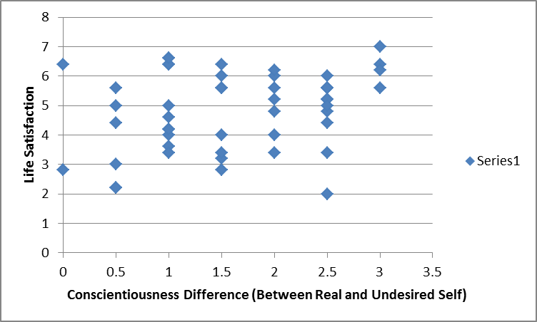

The correlation between Life Satisfaction and the ratings of Openness when comparing the Real Self and Ought Self was the second highest out of the composite scores, with a value of 0.25087. The differences between the rating of Openness of the Real Self and Ought Self for each participant in comparison to their life satisfaction were plotted on the scatterplot below:

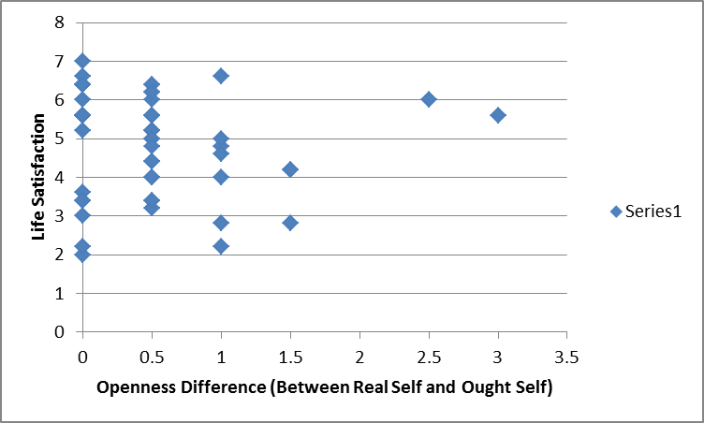

Out of all of the composite scores calculated, the one that had the lowest correlation was when comparing the ratings of Neuroticism between the Real Self and Undesired Self to the life satisfaction of each participant. The correlation between those two variables came out to be -0.1859. The comparison of these two variables is seen in the scatterplot below:

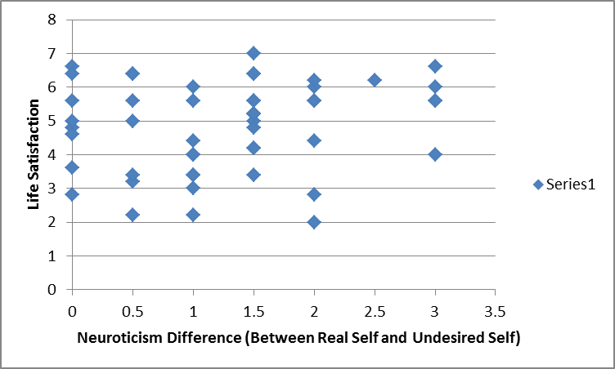

There were several other correlations that seemed to be significant in this study (including the correlation between the differences in ratings of Extraversion between the Real Self and Ought Self, which was 0.152), however these three results seem to be the most significant to the research question and hypothesis that is being tested.

Discussion

As I stated previously, the purpose of this study was to answer the question of whether or not the differences between the undesireable self, the real self, and the ought self has an effect on one’s life satisfaction (and what these effects are if there are any). Based on the first scatterplot shown comparing the Conscientiousness rating differences between Real and Undesired Self with Life Satisfaction, it is clear to see that the correlation between the two is positive and pretty high overall. This means that as the differences between the two “Self’s” increased, the rating of life satisfaction increased. I interpreted this as meaning that if the participants’ actual conscientiousness scores are higher than how conscientious they think their undesired self would be, they tend to be more satisfied with life. This is actually a pretty realistic result, because if one feels like they currently exude characteristics that they actually desire to have, that would more than likely make them more satisfied with themselves and their lives. Similarly, the correlational data comparing Life Satisfaction and the ratings of Openness when computing the difference between the Real Self and Ought Self ratings was the second highest out of the composite scores, with a value of 0.25087. After analyzing the second scatterplot that exhibited these results, I noticed that when the difference between the “Real Self” and “Ought Self” rating was 0 or less than 1, life satisfaction was significantly higher in comparison to when the difference between the two “Self’s” was higher. This also makes sense because as humans, we tend to strive to be as similar to our ought or “perfect” self as possible, so of course we would me more satisfied with life if we feel like we are emulating similar qualities of that perfected self. The third scatterplot, however, showed a negative correlation when comparing the difference between the ratings of Neuroticism of the “Real Self” and “Undesired Self” and the life satisfaction of each participant. This means that when the ratings of the participants’ current levels of Neuroticism were higher than that of the “self” that they did not want to be or become, they became less satisfied with their lives. Although this seems like it would be an inconsistent result it actually isn’t; neuroticism is often seen as a negative trait, so if the participant felt like he or she was starting to become more neurotic than what they desire to be, it would make sense for them to be less satisfied with their lives as a result of that.

After analyzing these findings, it seems as if the answer to the research question I proposed is yes, the differences between the undesirable self, the real self, and the ought self do have some type of effect on one’s life satisfaction. Ogilvie specifically mentioned that, when one compares their real self to their undesired self, they may end up having feelings of depression. Although I do not feel that it is safe to assume that all participants who answered these questions when comparing those two factors were depressed, it is clear that they were less satisfied with life when they thought that their real self was becoming more and more like their undesired self (which could eventually lead to depression). The same seems to be true when the differences in the participants’ ratings of openness between the Real Self and Ought Self decreased; the life satisfaction when this occurred seemed to be relatively higher in comparison to when the differences were increasing. Once a person feels as if they are becoming less open than people expect them to be, they become less satisfied with life and may develop anxiety as a result of this decreased satisfaction.

One limitation for this study was that the questionnaire only provided questions related to the “Big Five” personality traits. Although this made the study much simpler, I feel that it did kind of hinder the study because it didn’t give us as researchers a chance to really develop a detailed explanation for what emotions are evoked when different types of personality traits are rated besides those five. In the future, I think it would be important to not only provide questions in the questionnaire that refer to more than 5 personality traits, but I would also include more questions pertaining to how it makes each participant feel when their actual self is not living up to the standards that they think their ought self should have (or vice versa for the undesirable self). Also, another limitation for this specific study was that we did not ask each participant in the questionnaire whether they were male or female. Although we did ask them this question separately after they completed the questionnaire, we could not pinpoint whether the data that was collected from each submitted questionnaire was submitted by a male or female. Moving forward, I think if a similar study was done in the future, they should include a question about the gender of the participant in the questionnaire, so that the results of the males and females who participated in the study can be directly compared for further analysis. Having more specific questions overall that cover more specific personality traits would definitely make the study produce more conclusive results so that we as researcher can attribute more emotions to these self-differences besides either depression or anxiety.

Works Cited

Hong, R. Y., Triyono, W., & Ong, P. S. (2012). When Being Discrepant from One's Ideal or Ought Selves Hurts: The Moderating Role of Neuroticism. Eur. J. Pers. European Journal of Personality, 27(3), 256-270. doi:10.1002/per.1888

Ogilvie, D. M. (1987). The undesired self: A neglected variable in personality research. Journal of Personality and Social Psychology, 52(2), 379-385. doi:10.1037/0022-3514.52.2.379